Digital Chip Design Program
RTL Design
Alia Alsultan
Elaf Alkhalaf
Lana Aldhali
Manar Alnuqaydan

Task #07
13/07/2026

Sequential Datapath Design Part 1 - Blocking & Non-Blocking

Task #7.1

7.1.1

7.1.1.1

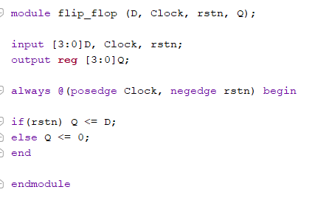

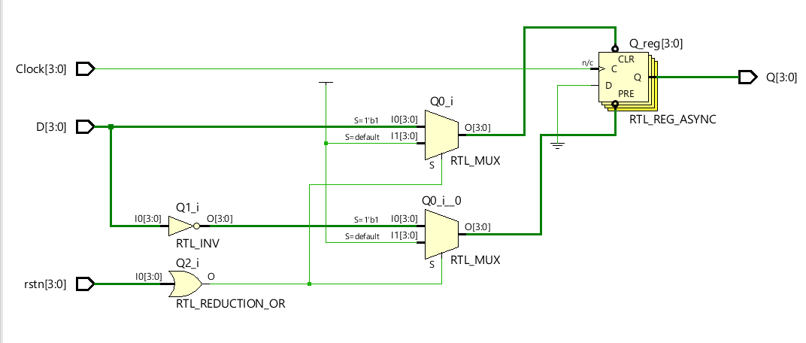

7.1.1.2

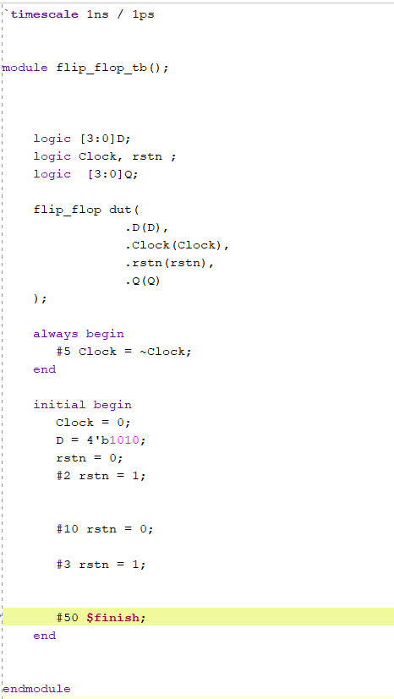

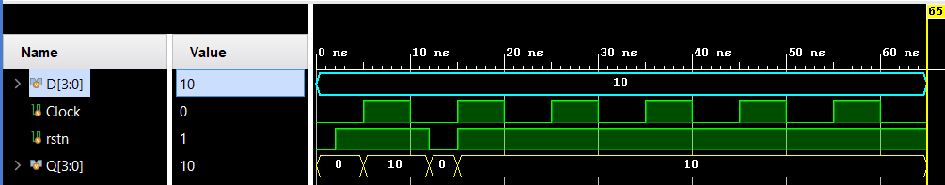

Task #7.2

7.2.1

7.2.1.1

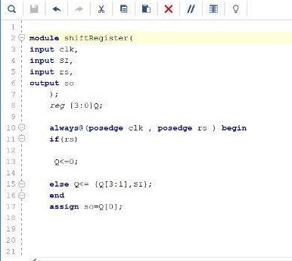

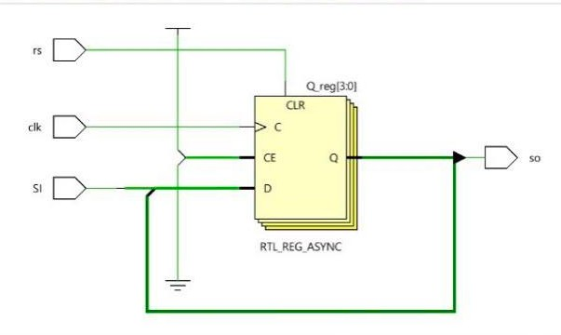

7.2.1.2
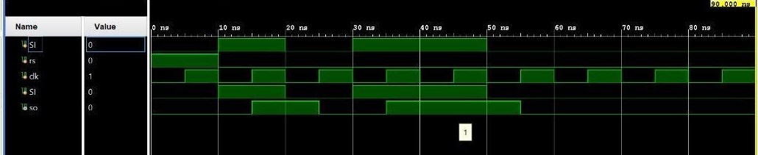

Task #7.3

7.3.1

7.3.1.1

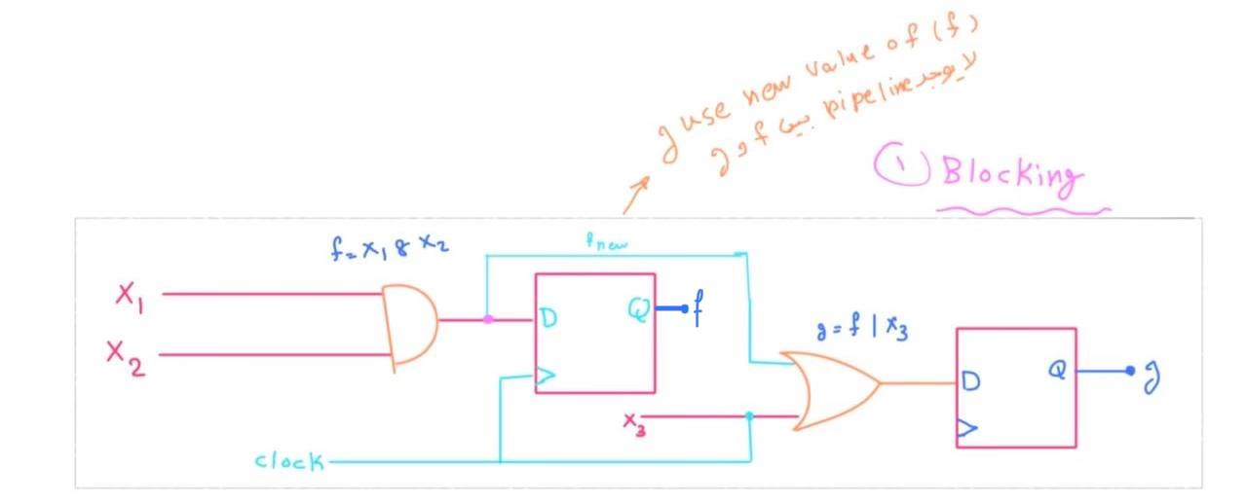

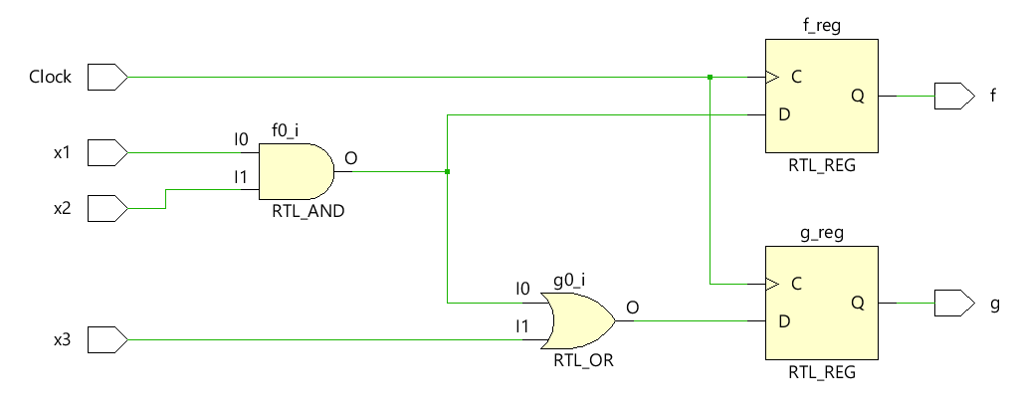

7.3.1.2

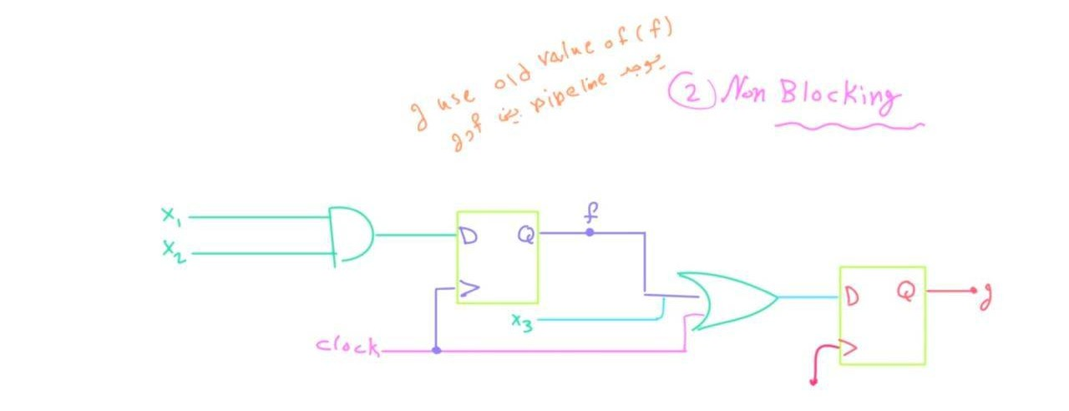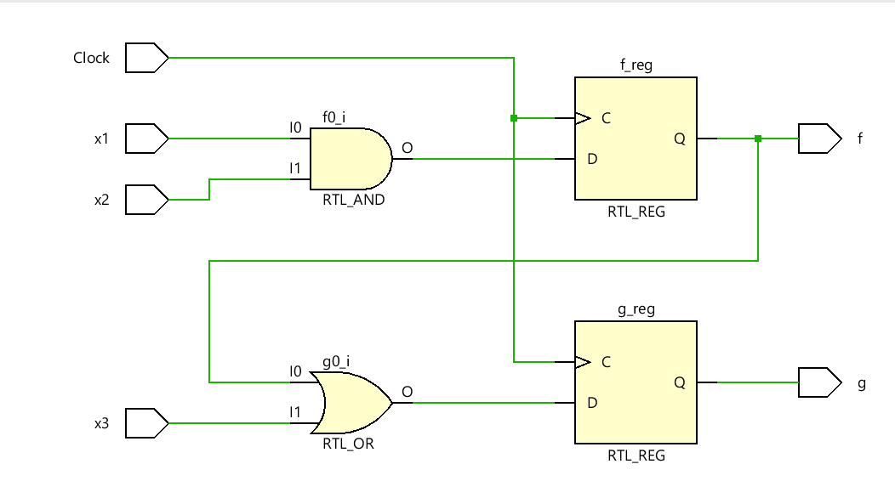

Work distribution

Section | Alia | Elaf | Lana | Manar
Report | ✔ | ✔ | ✔ | ✔
Task n.x | ✔ | ✔ | ✔ | ✔
Task n.x+1 | ✔ | ✔ | ✔ | ✔
Task | ✔ | ✔ | ✔ | ✔

